
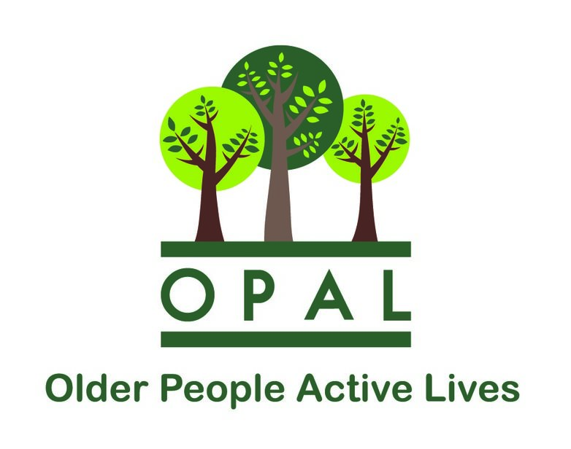


For tickets contact :
Jo on 01928 787899
Jo joquilter72@outlook.com
Juliet at julietcompston@googlemail.com

SOUP LUNCH FUNDRAISER

FRIDAY 18th MARCH
12.30pm – 2.30pm
FRODSHAM COMMUNITY CENTRE

Come along and enjoy a light lunch of soup followed by cake and a hot drink
while at the same time supporting OPAL
£5 per person + Raffle

